Feedback Report

Rachel Heke

Media Design School

NLP303: Natural Language Processing & Speech Recognition

Terence Mayne

25th March 2025

Feedback Report

**Feedback Source:**

This feedback was provided by a classmate who interacted with my chatbot as part of informal peer testing. The chatbot is a simple, rule-based assistant built using Python’s tkinter library.

**Feedback Summary:**

The classmate commented that while the chatbot functioned as expected in responding to queries (based on keyword matching), it was difficult to clearly distinguish between user messages and the chatbot’s responses in the chat log. This affected readability, especially during longer conversations.

**Interpretation of the Feedback:**

The suggestion indicated a need to visually separate messages from the user and the assistant (Grace). Without these visual cues, the dialogue felt blended and caused a slight usability issue. Although the chatbot is a simple 1-on-1 tool without API integration or complex NLP, enhancing the visual layout was still important to improve user interaction and conversation flow.

**Action Taken:**

To respond to this feedback, I implemented message styling using text tags in the tk.Text widget:

* Grace’s responses are now styled in italic purple text to make them appear distinct and friendly.

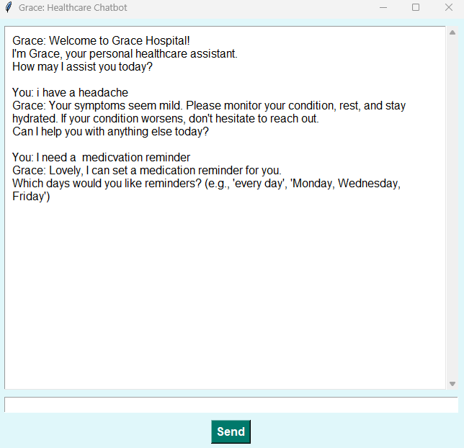

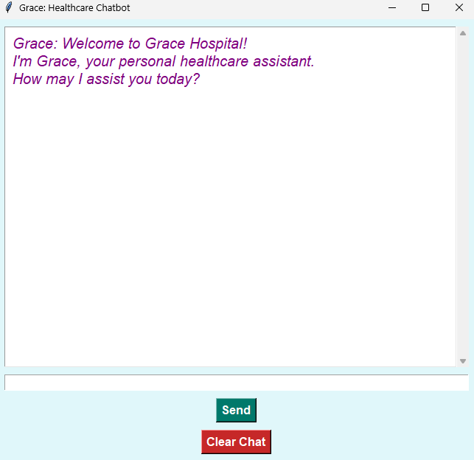

* User input is styled in bold blue text, making it easy to differentiate who said what.

* The changes were implemented using tag_configure and tag_add in tkinter, with custom colors and font styles applied to messages dynamically when inserted into the chat log.

**Limitations:**

Due to time constraints, I was not able to implement advanced features such as using a language model or API to manage varied user queries. The chatbot operates using a basic keyword intent matching system, and does not yet support conversation memory, natural language understanding, or context switching. However, the UI improvement significantly enhances usability within this scope.

**Outcome:**

The change resolved the original concern. Messages are now clearly distinguishable, making the chatbot easier to use and more user-friendly for those interacting with Grace.